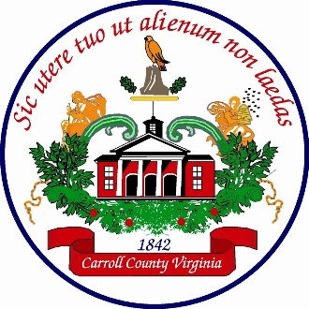
Tim Carpenter
Carroll County Building Official
276-730-3016 Office
276-733-1036 Cell
Building.Official@carrollcountyva.gov
AFFIDAVIT
FARM STRUCTURE EXEMPTION

Farm buildings and structures are exempt from the Virginia Uniform Statewide Building Code (VUSBC).
To qualify for this exemption, the structure MUST BE used for a specific purpose which is directly related to an operating farm. The Code of Virginia §36-97 and Section 102.3 (9) of the 2018 edition of the VUSBC defines a farm building/structure as follows:

FARM BUILDING OR STRUCTURE. A building or structure not used for residential purposes, located on property where farming operations take place, and used primarily for any of the following uses or combination thereof:

- Storage, handling, production, display, sampling or sale of agricultural, horticultural, floricultural or silvicultural products produced in the farm.
- Sheltering, raising, handling, processing or sale of agricultural animals or agricultural animal products.
- Business or Office uses relating to the farm operations.
- Use of farm machinery or equipment or maintenance or storage of vehicles, machinery or equipment on the farm.
- Storage or use of supplies and materials used on the farm.
- Implementation of best management practices associated with farm operations.

Such buildings or structures lying within a flood plain or in a mudslide-prone area are subject to floodproofing and/or mudslide regulations. This exemption does not apply to any building or portion thereof used or operated as a restaurant and licensed by the Board of Health.

In order to verify an understanding of the specific purpose for the proposed structure, please answer the following questions related to the activities conducted on the property.

- Is the property currently an active farm that is being used for the production of agricultural, horticultural, floricultural or silvicultural products intended for sale to domestic and/or foreign markets?

YES NO (please circle one)

- Is the property currently an active farm being used for the raising or processing of farm animals or farm animal products intended for sale to domestic and/or foreign markets?

YES NO (please circle one)

If you answered NO to the previous questions, the proposed structure IS NOT exempt from the USBC. If you answered YES to either of the previous questions, please continue to the next page.

- Is the proposed building/structure to be used for:

- The storage, handling or production of the products listed in question 1, or
- For the sheltering, raising or processing of the animals listed in question 2, or
- For the maintenance, storage or use of equipment related to the activities referenced in questions 1 or 2?
YES NO (please circle one)
If you answered YES to question 3, please complete the affidavit.

By completing the following affidavit, you are stating that the proposed structure meets the farm structure exemption of the 2018 VUSBC. There will be no inspections required or performed by this office. Presentation of a false affidavit would constitute a violation of Section 115 of the VUSBC. Presentation of a false affidavit may also constitute violations of other Federal, State or Local regulations which may be punishable separately. The structure is not exempt from the County of Carroll’s Erosion and Sediment Control Ordinance.

Owners Name:
Address and Parcel Tax ID # of Structure

I have read and understand the above and affirm that the structure proposed to be built qualifies as a “Bona Fide Farm Structure”.

County Agent Signature Date

